Early Research Report: Complex Networks Analysis

*Artem Vergazov*

*Research Advisor: Vladimir Palyulin*

Introduction

Many of the natural and artificial systems are represented efficiently by a notion of graphs, or networks. Thus, studying network science is very important for understanding the underlying principles of behavior of complex systems. Particularly, it is important to study the articulation points distribution in graphs. An articulation point in a network is a node whose removal disconnects the network. Being able to find articulation points and understanding the patterns of their behavior can help both prevent crucial systems from destruction (for example, designing more resilient infrastructure networks) or find weaknesses in such systems.

Furthermore, some phenomena today are better described by multiplex networks, rather than usual networks. A multiplex network is a collection of monoplex networks, or layers, where all the nodes exist simultaneously in all the layers but the links within each layer can differ. An obvious example of such system is a network of Facebook as one layer and a network of Twitter as the other. Nodes represent people participating in these networks, and links represent connections between them in each of the networks. It is obvious that a classical notion of a network would not be enough to describe such system.

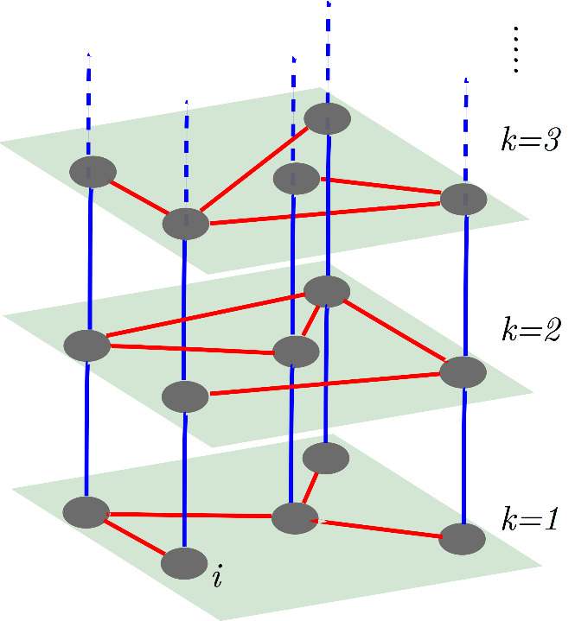

Having introduced these two notions: an articulation point and a multiplex network, – it is now safe to say that the main interest of our research is articulation points distribution in multiplex networks. It is a new topic in the field and not much work has been related to that previously.

Current results

So far, I have been studying the work related to articulation points [1] and multiplex networks [2, 3]. Also, I have reproduced the Figure 3a from [1] and confirmed the correspondence between the results from numerical simulations of random graphs and analytical predictions obtained in the paper regarding the distribution of articulation points:

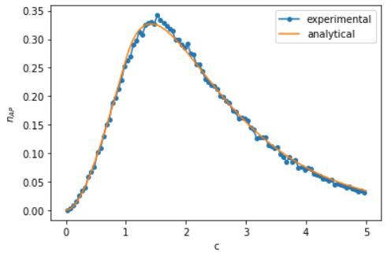

Plans

Next, we plan to reproduce some figures from [2] and, after having dealt with articulation points, dive deeper into multiplex networks simulations.

Literature

1. Tian, L. et al. Articulation points in complex networks. Nat. Commun. 8, 14223 doi: 10.1038/ncomms14223 (2017)
2. Buldyrev, S., Parshani, R., Paul, G. et al. Catastrophic cascade of failures in interdependent networks. Nature 464, 1025–1028 (2010). <https://doi.org/10.1038/nature08932>
3. Saeed Osat. Percolation on complex networks and its applications.